 | Student Name _______________________  Eastern Goldfields College  Mathematics Essentials 2015  Mental Test 2
 | Time allowed: 10 minutes Total Marks: 505 marks
CALCULATORS AND FILES ARE NOT ALLOWED
(1) Write an abbreviation for millilitres per  second. | (2) Write a rate for walking speed.
(3) Circle the better buy:  2 kg for $2.90 or 5kg for $7.50 | (4)  _1_  10 of hr =________ minutes?
(5) Round to the nearest 10 to estimate  624 - 54 x 38 | (6) What percentage of $10 is $2.50?
(7) If a tap drips at a rate of 25 millilitres per  minute. How many millilitres dropped  after 30 minutes? | (8) A loaf of bread increased in price by 10%.  Calculate the new price, if the old price  was $3.40.
(9) Convert 26 beats in 15 seconds to beats  per minute. | (10) E = 17p + 37f + 17c. If p is 10, f is 0  and c is 2, what is the value of E?
(11) Business envelopes come in boxes of  200. If 600 envelopes are needed, how  many boxes are required? | (12) There is a 5% discount on socks. If the  regular price for socks is $10, what is  the discounted price?
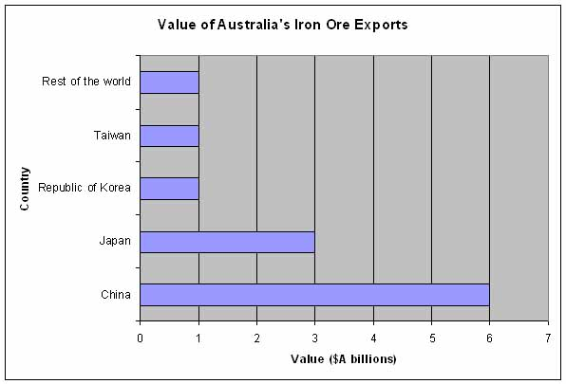 | (13) Which country had the highest Iron Ore  Export from Australia?  (14) What was the Value of the Export to  China?

